SRS Document

ONLINE BOOKMARKING APPLICATION

To: Prof. Lydia Jane G.

by-

Omprakash:(12BCE0068)

Deepak: (12BCE0512)

Shreyance: (12BCE0402)

**Problem Statement**

With the ever increasing number of websites and use of internet for numerous things, bookmarking important websites have significantly grown. But the present system has limited functionality, one cannot access their saved bookmarks from different computer. Our application will directly address this problem and provide mechanism to organize bookmarks, effectively manage them and the ability to access them from multiple devices.

**Background Information**

As we know that bookmarking webpages is a need of many. With increasing number of multipurpose computer devices, one need to access their bookmarks from multiple devices. The problem is, one cannot access the bookmarks saved on one device or one web browser on other. The target users here are all the people using internet who use bookmarks to save links and URL.

Their exist number of systems for saving bookmarks but none are similar to ours. The existing bookmarking systems are: the web browser integrated bookmarking systems which are available in all major web browsers such as Google Chrome, Mozilla Firefox, Internet Explorer, Opera, Safari, etc.

The limitations of existing systems is absence of universal accessibility of saved bookmarks and no proper organization of the same. One cannot access their saved bookmarks from other web browsers and/or other computer systems. Also the present systems have limited functionality in organization of saved bookmarks. Our application will provide universal accessibility of user’s saved bookmarks and easy classification and organization of the same.

**Stakeholders**

* Project Development and Design Team
* Customers/Users

**Requirements**

* **Functional Requirement**
  1. Register
  2. Log in
  3. Add New Bookmark
  4. Save Current Page as Bookmark
  5. Create Category
  6. Manage Category
  7. Edit Bookmark
  8. Manage Bookmarks
  9. Delete Bookmark
  10. Update and Manage Application

User Stories:

1. Register:   
   As a new user I would like to register on your bookmark application. So that I can save bookmarks and access them from my multiple computer devices.
2. Login:   
   As an existing user, I would like to log in to my account to access my saved bookmarks.
3. Add New Bookmark:   
   As a current user of the application I would like to add a new bookmark in my Entertainment category of Bookmarks in my account.
4. Save Current Page as Bookmark:   
   As a logged in user in your application I would like to save the current webpage as a new bookmark in your application in the uncategorised section of Bookmarks.
5. Create Category:

As a user of the application I would like to create a new category for storing my bookmarks category wise.

1. Manage Category:

As a user of the application, I want to manage my bookmark categories by renaming and reordering them.

1. Edit Bookmark:   
   As a user of the application I would like to edit the name of a bookmark stored in my account under Social Networks category.
2. Manage Bookmarks:  
   As a user of the application I want to manage my saved bookmarks and categories.
3. Delete Bookmark:   
   As a registered user of the application I would like to delete my saved bookmark as I don’t use or need it anymore.
4. Update and Manage Application:  
   As a project development team member I would like to update the bookmarking application.

**Use Case Diagram:**

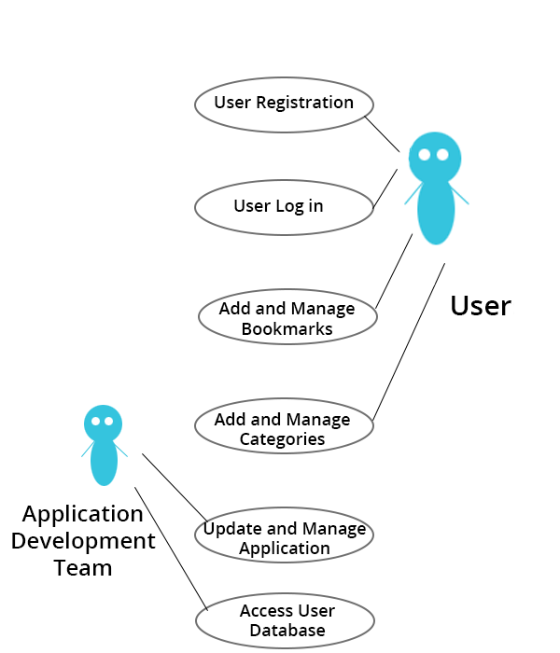

* **Non Functional Requirements**
* [Accessibility](http://en.wikipedia.org/wiki/Accessibility):   
  Anyone can use the application, there is no restriction to any person. The application can be accessed from the following internet enabled browsers:   
  Google Chrome, Mozilla Firefox and Internet Explorer (Version 8 and above). And minimum system specification required are: 500MB RAM, Core2Duo or higher processor.
* Security:   
  The application will be hosted on safe and secure cloud servers. All the registration information of the users will be safe and secure and will not be shared with any third party and the email will not be spammed.
* Failure Management:   
  In case of any disaster or unexpected failure the user’s data will not be compromised because it will be stored on reliable servers. And the application will be up and running within 1 hour in case of unexpected failure.
* Price:   
  The application is free to use. No charges of any kind to use the application will be collected.
* Response time:   
  The response time of the application will depend on the bandwidth of the internet at which the user is accessing the application. However the minimum time to load the application from our server side will be not more than 1.5 sec.
* Usability:   
  It will be extremely easy to use the application. It would take about 3 minutes to get to know all the features of application and how to use it. The new user registration will take 30 seconds.
* Scalability:   
  The application will be designed keeping in mind the population using the internet and so there will be real time monitoring of number of users registering for it and the extra window will be implemented. Also since the application will be hosted on cloud based servers, they can be unscaled anytime according to requirement.